**Home Page**

**Ecopack India – Specializes in Silica Gel, Desiccants & Moisture Absorbent Products.**

**Ecopack** India is one of the leading manufacturers of Silica Gel, Desiccants and Moisture Absorbent products. Our wide range of products like Silica Gel, Molecular Sieves, Alumina Balls, Activated Bentonite Clay, Super Gel, Other Primary Packaging Desiccants & Oxygen Absorbers are in high demand across industries.

Our goal is to protect your products from the damaging effects of moisture and humidity. We serve the demands of the industry through strategic packaging solutions and specialized care.

We are committed to finding long-lasting effective solutions for humidity problems like moisture absorbing packets and container dry. We have a dedicated and experienced team of professionals who work round-the-clock to provide best quality products in the fastest time possible. Long hours are spent on designing, fabrication and testing procedures of different prototypes to find the best solutions for your products. Get in touch with us today for more

# Why Use Silica Gel / Desiccant / Moisture Absorbent

Desiccant products are difficult to be replaced. And [Silica Gel](https://www.sercalia.com/en/silica-gel/) is one of them, probably the best known for its many applications.

The origin of the problem is the humidity, a factor that may deteriorate the majority of products if remaining long time in contact with them. In this way food, medicine, clothing, electrical appliances, photographic equipment, documents and almost any product can be damaged in contact with moist environments.

Obviously, not everything is ventilable, so it is necessary to control the increase of moisture with products that can absorb it. One of our products that is silica gel, silicon dioxide that looks like a porous sand in granular form.

The high porosity of the desiccant silica gel allows the absorption of environmental water up to 30% of its weight, so it is the desiccant that is capable of absorbing more water. Moreover, silica gel is non-toxic, non-flammable and does not harm your product and user too, so it can be considered a “clean” product, such as sand.

All these qualities ensure Silica Gel is good to for many applications & products where it was necessary to get dry environments.

**Moisture Damage**

Product suffer from mildew, stain, swelling, rust, oxidation, deformation, decayed and a series of qualitative change due to damages caused by moisture.

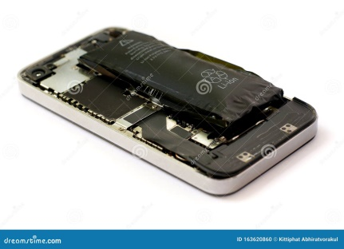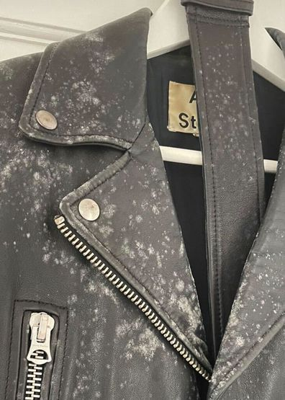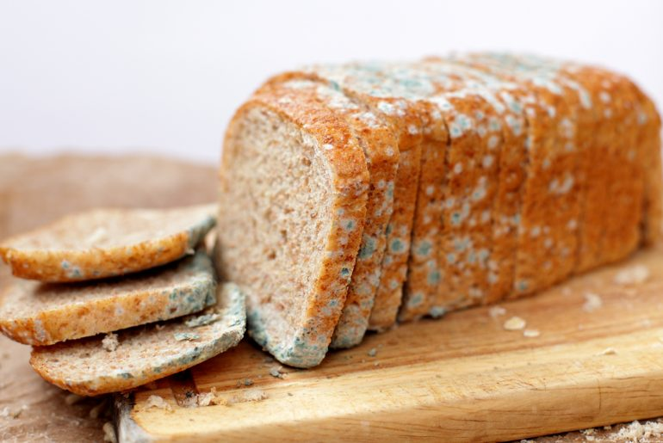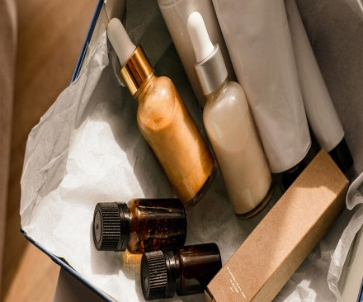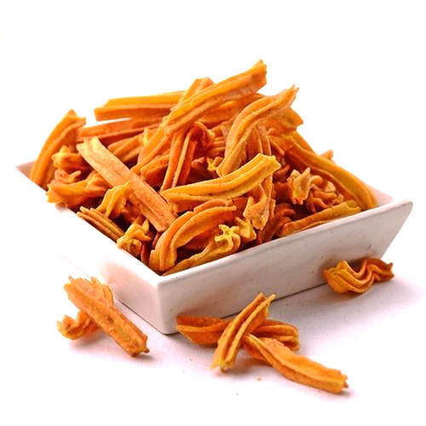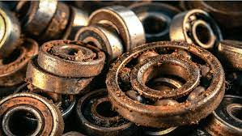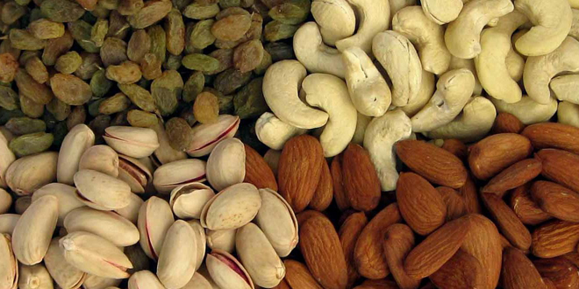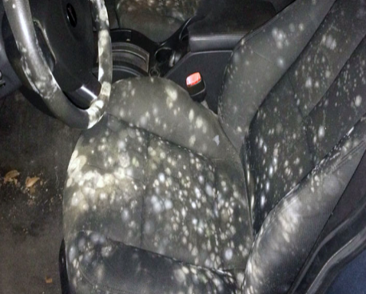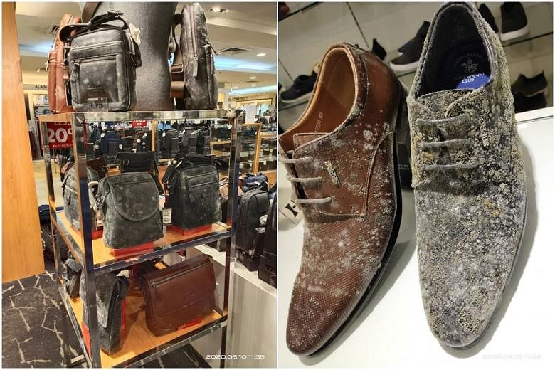

­c

Effectively solve the problem of dampness of your products.

**Product Characteristics**

Silica gel desiccant can effectively absorb more than 30% of it’s weight moisture from the air. It doesn’t change it morphology after absorption of moisture, it has good thermal stability and good mechanical strength, non-toxic in nature, harmless, non-pollution, it is the FDA approved desiccant that can be directly in contact with food and medicine.

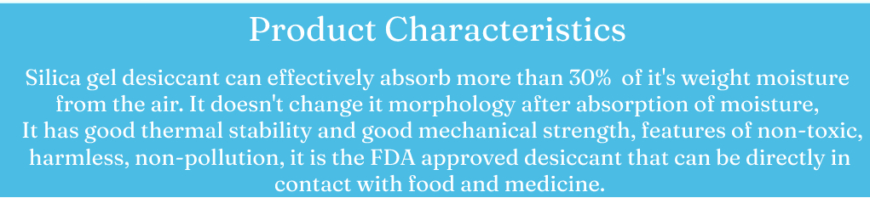

* 30% moisture absorption rate
* Non-toxic
* Non-pollution
* Good heat stability
* No smell
* High mechanical strength
* Non-corrosive
* FDA approved desiccant

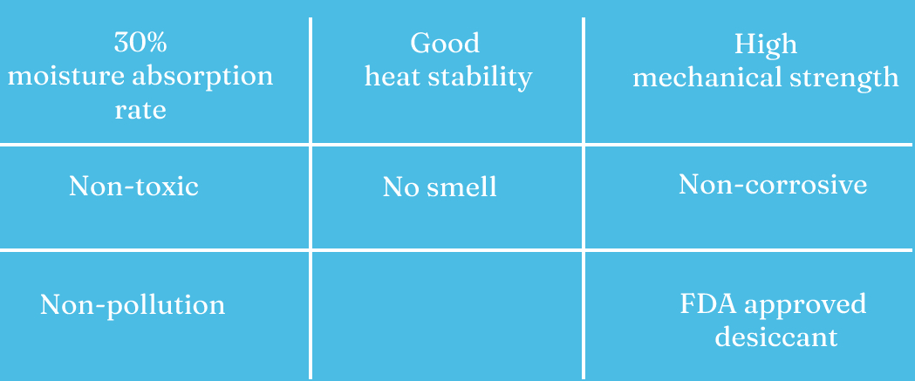

**INDUSTRIES WE serve**

## THE RIGHT PRODUCT FOR EVERY APPLICATION

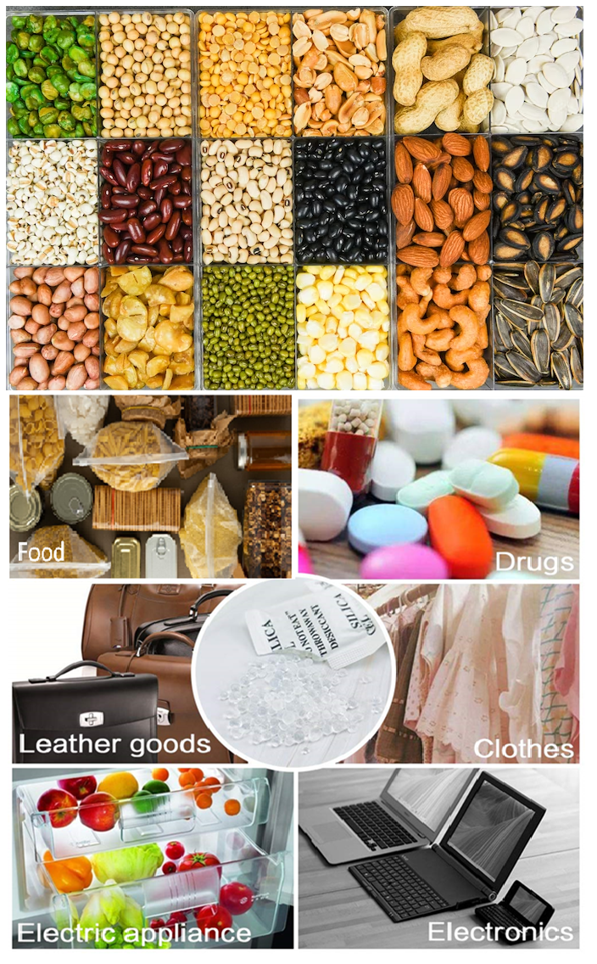

**About Us**

## **WHO WE ARE!**

We ‘**Ecopack India**’ would like to introduce ourselves as a quality conscious manufacturer of Industrial Desiccant / Silica Gel & Moisture Absorbent products. Our wide gamut of products includes Silica Gel White & Blue, Silica Gel Bags & Pouch Packing at 1 grams to 2 kg. In a very short duration of our establishment, we have achieved a significant growth in the industry. We believe in credibility and providing fast delivery of quality products at the doorsteps of our valued customers

## **OUR INFRASTRUCTURE**

We have a rich and sound manufacturing unit consisting all the necessary machineries of latest technology. Our company USP lies in a fully-automatic line for packing Silica Gel in imported paper. Our team of chemical and mechanical engineers are committed to provide you quality silica gel. To make sure that there remains no-defect in the end product, strict quality checking is done. We have introduced a modern Quality Control Mechanism which includes latest techniques for checking the quality of our products. We have our own laboratory where these chemicals are tested at both pre and post manufacturing stages.

Dust free workshop, warehouse and laboratory Ecopack India always attaches great importance to products quality, use clean workshop and advanced equipment to produce. Our raw material and finished products are testing in our laboratory to ensure better products to customers.

* We have 10000 level dust-free workshop
* We have spacious and tidy warehouse for storing raw materials and finished products
* We have advanced equipment and clean laboratory
* We have a team of skilled workers

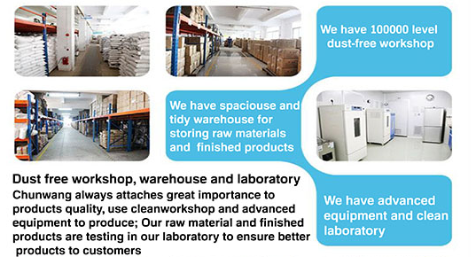

## **OUR TEAM**

**We have a team of skilled workers, highly efficient logistics team, a professional sales and marketing team and intimate after sale service team**

**We have a team of skilled workers**

**A professional sales and marketing team and intimate after sale service team**

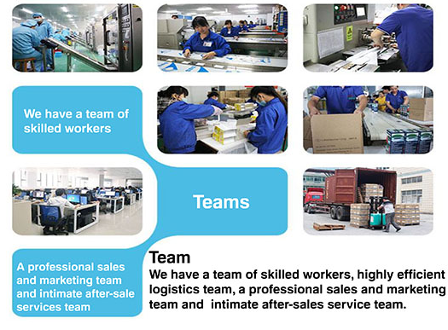



**Our Promise**

We promise our customers that we are committed to doing our best to provide our customers with high-quality silica gel desiccant / Moisture absorbent products.



1. Never use recycled materials, scraps and tailings.
2. Bulk silica gel with less than 5% water content.
3. Ensure that the moisture is absorbed upto 30%.
4. Food and pharmaceuticals grade package material absorption rate is 30%.
5. Non-toxic harmless ink ensure printing is clear and do not fade.
6. Advanced heat sealing machine, to ensure that silicone desiccant package is not easy to break.
7. The cartons are provided to prevent the goods from damage.
8. Sufficient capacity to deliver goods.

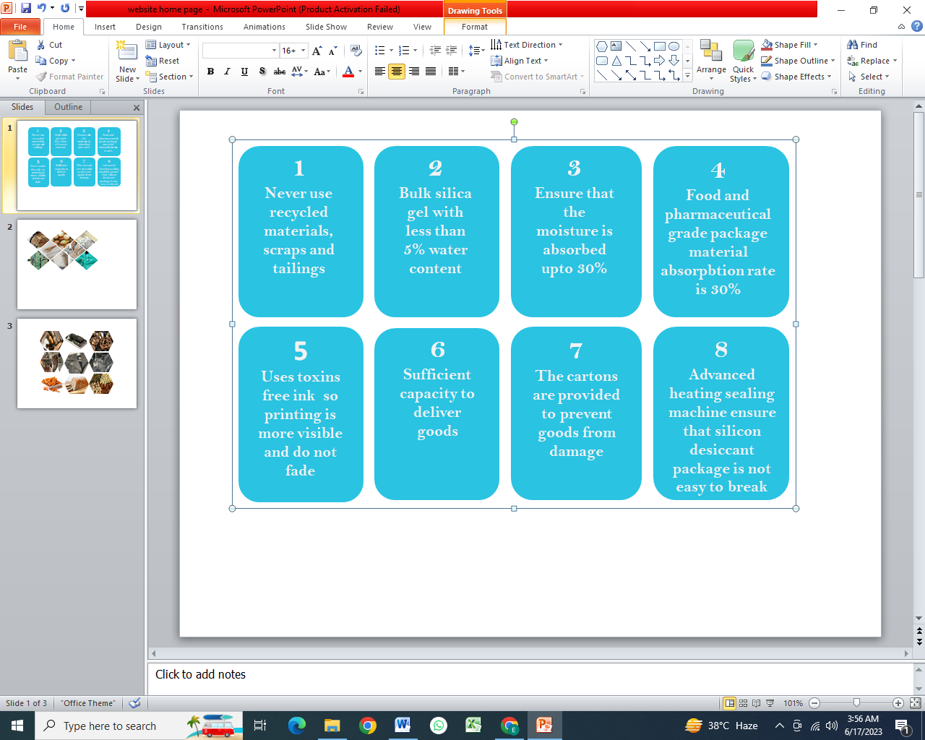

**Product packing and transportation**

**We use thick plastic bags and cartons, cartons on pallet to ensure that the goods are in good condition**



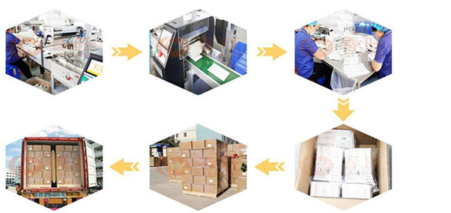

**SHIPMENT & PAYMENT**





Free samples will provided within 3 days confirmation



